

**www.oldfordacademy.org**

**Issue 39**

**Friday 22nd July 2016**

**100% ATTENDANCE 2015/16 WINNERS**

Well done to all pupils who achieved an amazing 100% attendance by coming to school every day and earned a chance to win an Acer tablet. The pupils also took part in the 100% attendance party. Throughout the year classes with the best half term attendance have enjoyed prizes such as movie experiences, extra ICT time and trips to Victoria Park.

Congratulations to Daviana Romney, 4 green, winner of the Acer tablet. Here is what a year 3 pupil said at the party: *‘When I was a little bit unwell, I asked my mum to take me to school because education is important’.*

|  |  |  |  |  |  |  |  |  |  |  |  |  |
| --- | --- | --- | --- | --- | --- | --- | --- | --- | --- | --- | --- | --- |
| Akinbobola Durodola | N Red | Brooklyn Jolugbo | 4 Red | | | | Tasneem Ahmed | | | 6 Blue | | |
| Nusaybah Abdullahi | 1 Blue | Dalmar Abdi | 4 Blue | | | | Jumana Ahmed | | | 6 Blue | | |
| Khadijah Uddin | 1 Blue | Sadiyah Ahmed | 4 Blue | | | | Maria Ahmed | | | 6 Blue | | |
| Yaseen Ramin | 1 Green | Arman Ali | 4 Blue | | | | Shariqa Aktar | | | 6 Blue | | |
| Malakai Julien | 1 Red | Kayif Yusuf | 4 Blue | | | | Arifa Begum | | | 6 Green | | |
| Zishan Kabir | 1 Red | Riyaz Ahmad | 4 Green | | | | Sabeena Begum | | | 6 Green | | |
| Nadia Yasmin | 1 Red | Kareem Caprice | 4 Green | | | | Ahmed Dalmar | | | 6 Green | | |
| Malakai Julien | 1 Red | Damilola Durodola | 4 Green | | | | Mama Diop | | | 6 Green | | |
| Zishan Kabir | 1 Red | Riyaana Jama | 4 Green | | | | Hibah Hussain | | | 6 Green | | |
| Nadia Yasmin | 1 Red | Maisha Khatun | 4 Green | | | | Uzair Uddin | | | 6 Green | | |
| Yusra Shariff | 2 Blue | Amber Lau | 4 Green | | | |  | | |  | |
| Junia Ahn | 2 Green | Abdullahi Mukhtar | 4 Green | | | |  | | |  | |
| Ayub Bin-Ashraf | 2 Green | Daviana Romney | 4 Green | | | |  | | |  | |
| Mahdiya Mahasin | 2 Green | Sameer Haque | 5 Red | | | |  | | |  | |
| Juraij Uddin | 2 Green | Kawsar Al-Kawsar | 5 Blue | | | |  | | |  | |
| Ryan Miah | 3 Blue | Isra Uggaasssharif | 5 Blue | | | |  | | |  | | | |
| Shamil Ishfaque Sarwar | 3 Blue | Shaez Ahmad | 5 Green | | | |  | | |  | | | |
| Abdirahman Abokor | 3 Green | Nafisah Anjum | 5 Green | | | |  | | |  | | | |
| Tahmidur Rahman Khan | 3 Green | Zakiyah Begum | 5 Green | | | |  | | |  | | | |
| Amelie Garcia Ferreira | 3 Green | Dimitri Julien | 5 Green | |  | | |  | |
| Mahdi Hasan | 3 Green | Tasneem Taher | 5 Green | |  | | |  | |
| Rayyan Hussain | 3 Green | Tayyiba Uddin | 5 Green | |  | | |  | |
| Tahmidur Rahman Khan | 3 Green | Eniola Abimbola | 5 Red | |  | | |  | |
|  |  |  | |  | |  | | |  | |
|  |  |  | |  | |  | | |  | |
|  |  |  | |  | |  | | |  | |
|  |  |  | |  | |  | | |  | |
|  |  |  | |  | |  | | |  | |
|  |  |  | |  | |  | | |  | |

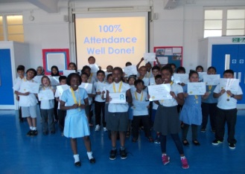

**VALUE AWARDS**

Nadira - RR

Giulia - RR

Aqeelah - RR

**STAR PUPILS**

**Reception** – Kamruzzaman, Eva, Imtiazur. **Year 1 –** Tahrima, Hilmey,

Zaynab, Mujahid, Kahdija.

**Year 2** – Habeeba, Malachi, Yusuf, Jameel.







**MUSIC NEWS – A LOOK BACK OVER THE YEAR.**

The Autumn term saw street dance workshops with Urban Strides and a huge singing inset with all Paradigm Trust staff, Directors, Principals, teachers, teaching assistants from all four academies at Ipswich Academy.

After Christmas break it was straight into the Young Voices at the O2 Arena. We followed it up with a concert for families and carers at school. We had a real party and Kelly made lots of amazing cakes.

EYFS staged a brilliant performance of Jungle book and after a crowd funding

campaign we managed to take ALL of year 6 from Old Ford and Culloden to the

West End to see Matilda the musical. Year 6 worked so hard, the singing was

amazing this year and the lead characters showed so much talent and courage to

deliver a very grown up performance. We had special musical workshops, a radio

station launch and lots of mindfulness in lessons. Our summer concert was amazing

everyone sang and performed brilliantly and we cannot

wait for next year’s summer concert!

Next year is a year of achievement, community and wellbeing.

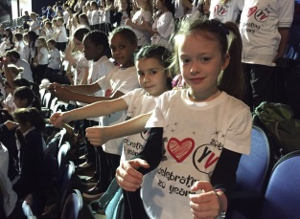

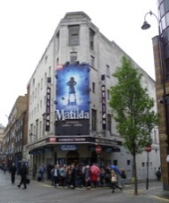

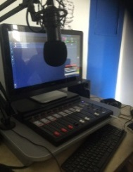

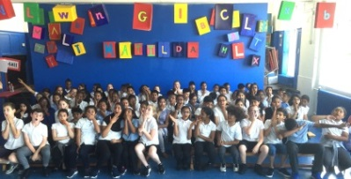

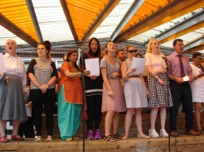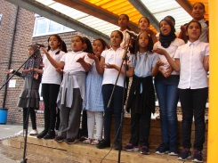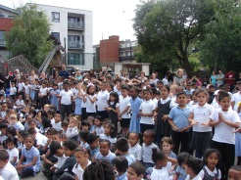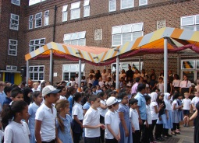

**PERSONAL FINANCE EDUCATION**

As part of their studies on Pfeg (Personal Finance Education), Year 2 learnt about the importance of giving money to charity.  The pupils took part in a Spellathon, where they were sponsored to learn to spell a set of words.  In total the pupils raised £141.53.  The pupils chose to donate this money to Save the Children. Thank you to all the parent/carers, friends and family who donated money.



**PLANNING FOR EID-UL-ADHA**

The Council of Mosques in Tower Hamlets has advised the local authority that the Islamic Festival of Eid-Ul-Adha is projected to occur on Monday 12th September 2016 but this will be subject to the sighting of the moon in Mecca. There is the possibility that Eid-Ul-Adha could occur on Sunday 11th September 2016. At present, schools are advised to consider scheduling a closure for Monday 12th September 2016.

**INSET DAY SEPTEMBER 2016**

**Old Ford Primary Academy will be closed to pupils for staff INSET training days on Thursday 1st September and Friday 2nd September 2016.**

All pupils will be expected to return to school on Monday 5th September 2016 at 8.55am.

**PHONE NUMBERS**

Please make sure that the administration team have your correct mobile/home phone number.  We use a text service called Groupcall to send out important messages and unless we have your correct details, you won't receive them!

**SCHOOL UNIFORM**

Please could all parents/carers ensure that they label their child's clothing.  Unless it is named, it is very difficult to find the owner and the item ends up lost!